**INTRODUCTION TO JAVASCRIPT**

**What Is Scripting ?**

* Scripting refers to a series of commands that are interpreted and executed sequentially and immediately on occurrence of an event.
* This event is an action generated by a user while interacting with a Web page.
* Examples of events include button clicks, selecting a product from a menu, and so on.
* A scripting language refers to a set of instructions that provides some functionality when the user interacts with a Web page.
* Scripting languages are often embedded in the HTML pages to change the behavior of the Web pages according to the user’s requirements.

**There are 2 Types of Scripting Languages**

1. Client-Side Scripting
2. Server-Side Scripting

**Client-Side Scripting**

Refers to a script being executed on the client’s machine by the browser.

**Server-Side Scripting**

Refers to a script being executed on a Web server to generate dynamic HTML pages.

**JavaScript - Client-Side Scripting**

* JavaScript is a scripting language that allows building dynamic Web pages by ensuring maximum user interactivity.
* JavaScript language is an object-based language, which means that it provides objects for specifying functionalities.
* In real life, an object is a visible entity such as a car or a table having some characteristics and capable of performing certain actions.
* Similarly, in a scripting language, an object has a unique identity, state, and behavior.
* The identity of the object distinguishes it from the other objects of the same type.
* The state of the object refers to its characteristics, whereas the behavior of the object consists of its possible actions.
* The object stores its identity and state in fields (also called variables) and exposes its behavior through functions (actions).

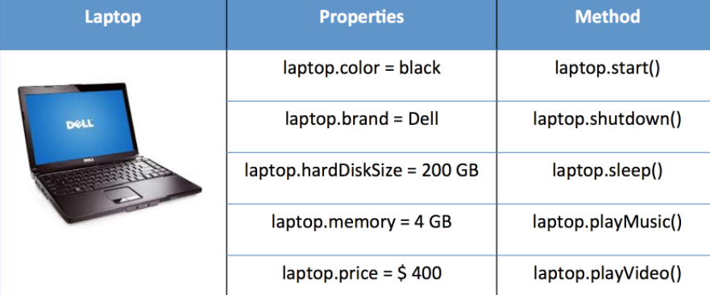

**Versions Of JavaScript**

The first version of JavaScript was developed by Brendan Eich at Netscape in 1995 and was named JavaScript 1.0.

**Following table lists the various versions of JavaScript language**

|  |  |
| --- | --- |
| **Version** | **Description** |
| 1.1 | Is supported from 3.0 version of the Netscape Navigator and Internet Explorer. |
| 1.2 | Is supported by the Internet Explorer from version 4.0 |
| 1.3 | Is supported by the Internet Explorer from version 5.0, Netscape Navigator from version 4.0, and Opera from version 5.0. |
| 1.4 | Is supported by servers of Netscape and Opera 6. |
| 1.5 | Is supported by the Internet Explorer from version 6.0, Netscape Navigator from version 6.0, and Mozilla Firefox from version 1.0. |
| 1.6 | Is supported in the latest versions of the Internet Explorer and Netscape Navigator browsers. It is also supported by Mozilla Firefox from version 1.5. |
| 1.7 | Is supported in the latest versions of the Internet Explorer and Netscape Navigator browsers. It is also supported by Mozilla Firefox from version 2.0. |

**Client Side JavaScript (CSJS)**

* A Client-side JavaScript (CSJS) is executed by the browser on the user’s workstation.
* A client-side script might contain instructions for the browser to handle user interactivity.
* These instructions might be to change the look or content of the Web page based on the user inputs.
* Examples include displaying a welcome page with the user name, displaying date and time, validating that the required user details are filled, and so on.
* A JavaScript is either embedded in an HTML page or is separately defined in a file, which is saved with .js extension.
* In client-side scripting, when an HTML is requested, the Web server sends all the required files to the user’s computer.
* The Web browser executes the script and displays the HTML page to the user along with any tangible output of the script.

**Server Side JavaScript (SSJS)**

* A Server-side JavaScript (SSJS) is executed by the Web server when an HTML page is requested by a user and the output is displayed by the browser.
* A server-side JavaScript can interact with the database, fetch the required information specific to the user, and display it to the user.
* Server-side scripting fulfills the goal of providing dynamic content in Web pages.
* Unlike client-side JavaScript, HTML pages using server-side JavaScript are compiled into bytecode files on the server.
* A JavaScript is either embedded in an HTML page or is separately defined in a file, which is saved with .js extension.
* Compilation is a process of converting the code into machine-independent code.
* This machine-independent code is known as the bytecode, which is an executable file that the Web server runs to generate the desired output.

**Information About <Script> Tag**

* The **<script>** tag defines a script for an HTML page to make them interactive.
* The browser that supports scripts interprets and executes the script specified under the **<script>** tag when the page loads in the browser.
* You can directly insert a JavaScript code under the **<script>** tag.
* You can define multiple **<script>** tags either in the <head> or in the <body> elements of an HTML page.
* In HTML5, the type attribute specifying the scripting language is no longer required as it is optional

**The Code Snippet demonstrates the use of the <script> tag**

<!doctype html>

<html>

<head>

<script>

document.write(“Welcome to the Digital World”);

</script>

</head>

<body>

.....

</body>

</html>